**Database Format**

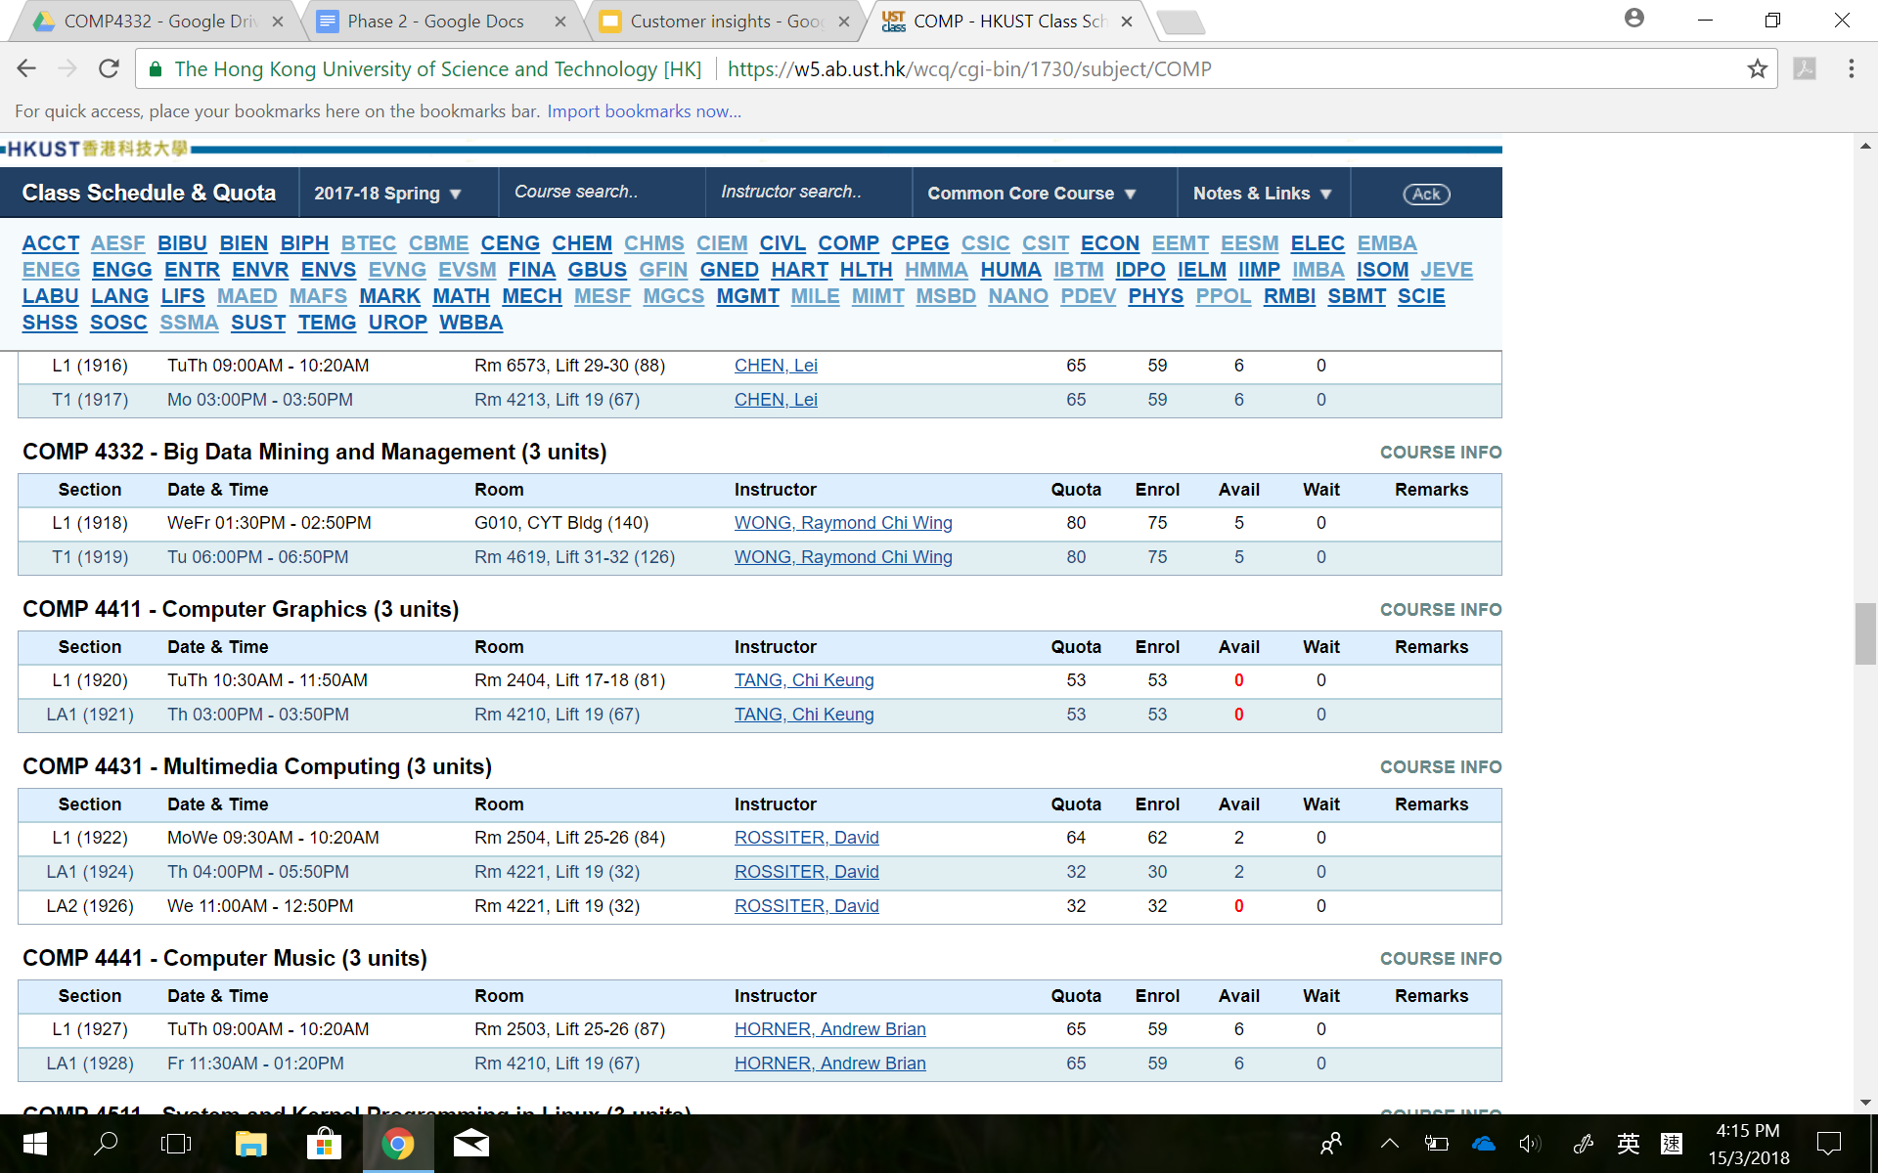

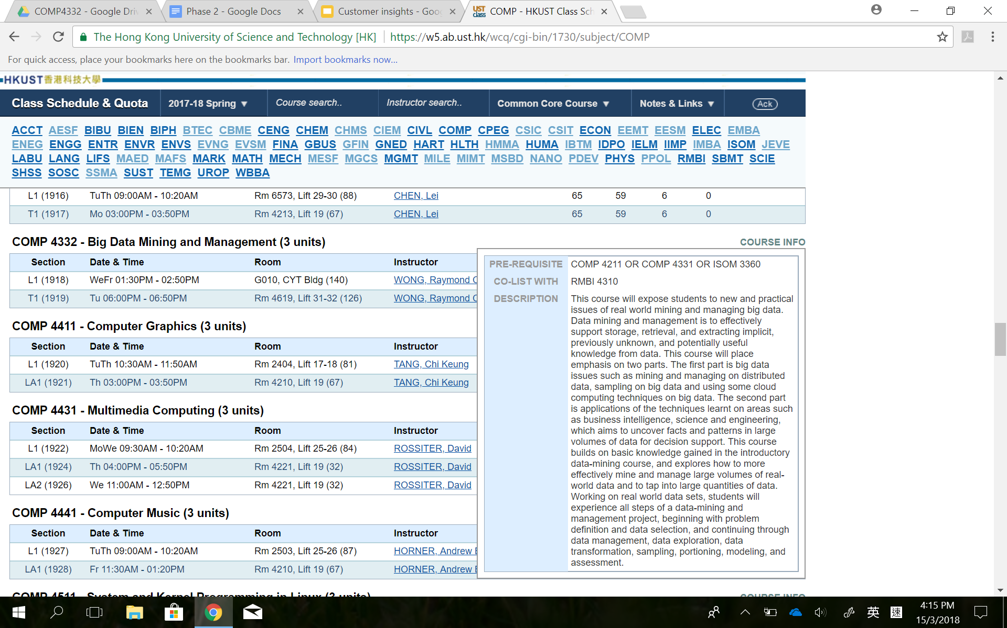

We categorize the data of a course into course level and section level.

Fields in the course level do not change across time slots. They are further segmented to:

* Mandatory: code, ctitle, credit, description
* Optional: prerequisite, corequisite, colist

Fields in the section level can be changed across time slots. Therefore the information of time slot is stored in the section level. The fields are further segmented to:

* Mandatory: section, room, instructors, quota, enrol, avail, wait
* Optional: remarks

**Insertion**

**Query**